**A or An**

Fill in the gaps.

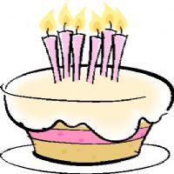…..cake 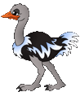……ostrich 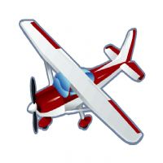  airplane             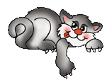 cat

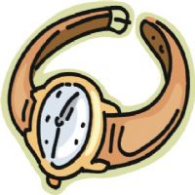……watch 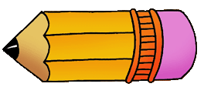 …..pencil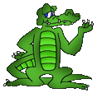    alligator       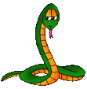 snake

….apple http://www.englishexercises.org/makeagame/my_documents/my_pictures/2009/feb/4ZC_1snowman001-thumb.jpeg…..snowman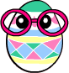  egg                    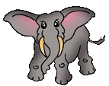 elephant

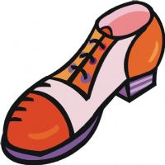….shoe …..ice-cream

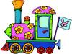   train             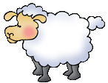 sheep

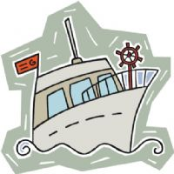 yacht             http://www.englishexercises.org/makeagame/my_documents/my_pictures/2009/feb/B3Z_c0103.gif   bird         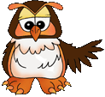…..owl 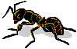     ant http://www.englishexercises.org/makeagame/my_documents/my_pictures/2009/feb/D49_ca0007.gif….bear

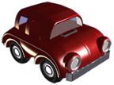  car                    http://www.englishexercises.org/makeagame/my_documents/my_pictures/2009/feb/3E7_art0003.gif    brush

 door        finger         knee          church

 tractor             insect          girl          ear

 dress             colour         letter          school

 alarm clock       flag            curtain

 woman     umbrella        newspaper     rubber

**Select  a  or  an**

I have got ……..big shirt.

She has got ……orange ribbon.

I'm ……Swedish girl.

He is …….English boy.

What …….old man!

Give me …….pencil, please.

I can see ……yellow car.

There is ……cat.