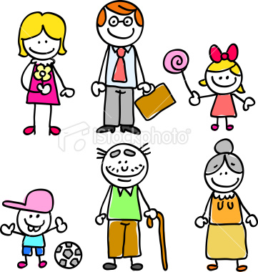

**MY FAMILY**

This is my _________

This is my _______

This is my _________

This is my _________

This is my _________

This is my _________