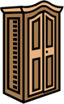
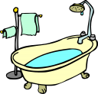
1
2
IN THE HOUSE
Fill in the crossword and find the hidden words.

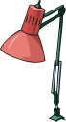
12
1
2

3
4
5
6
7
8
9
10
11
13
14
15
16
17
18
?
19
3
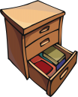
4

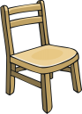
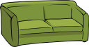
5
6


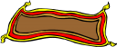
7
9

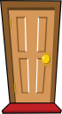
12
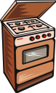
8


18

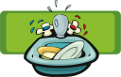
17

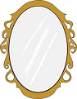
10
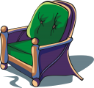
11

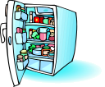
19
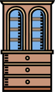
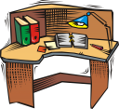
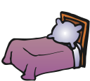
13
14
15

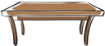
16
KEY
R
O
O
D
12
W
D
R
A
1
R
O
B
E
B
A
B
H
T
U
T
2

L
M
P
A
3
D
R
A
W
E
R
S
F
C
E
S
O
H
T
4
C
H
R
A
5
I
S
O
F
A
6
C
P
Y
A
L
D
R
E
7
R
O
K
C
O
E
8
U
R
G
9
M
R
R
I
R
O
10
R
A
R
C
M
H
A
I
11
D
R
A
U
C
P
O
B
13
D
S
14
K
E
E
D
B
15
E
L
A
T
B
16
I
S
K
N
17
E
A
S
K
C
O
B
O
18
F
I
R
?
E
G
D
19

