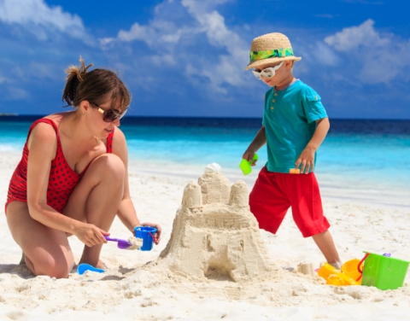
INITIAL TEST
Vth grade

Name:……………………………………………………………….Date :…........………………………………………...

VOCABULARY – 30 marks

- Fill in the gaps using the following words: surfer, them, to make, can, called, beach, dolphins, shells, sand, year.

Our Vacation
Every …………………….. we go to Florida. We like to go to the …………………..
My favorite beach is ……………………. Emerson Beach. It is very long, with soft sand and palm trees. It is very beautiful. I like …………………..sandcastles and watch the sailboats go by. Sometimes there are ……………………. and whales in the water!
Every morning we look for shells in the …………………….... I found fifteen big…………………... last year. I put …………... in a special place in my room. This year I want to learn to surf. It is hard to surf, but so much fun! My sister is a good ……………….... She says that she ……………….. teach me. I hope I can do it!
(10x2m=20m)
- Answer the questions.

- What’s your name?____________________________________________________________
- How old are you?______________________________________________________________
- Have you got any brothers or sisters?______________________________________________
- What’s your nationality?________________________________________________________
- Where do you live?_____________________________________________________________
- What’s your mother’s name?_____________________________________________________
- Have you got a pet?_____________________________________________________________
- Do you like animals?_____________________________________________________________
- Can you ride a bike?_____________________________________________________________
- What school subject do you like?__________________________________________________
(10x1m=10m)

GRAMMAR- 30 marks
- Underline the correct words:

- What …………………………………….now? a) do you do b) are you doing c) you don’t do
- Mother………………………….every Monday. a) wash b) is washing c) washes
3. Listen! The children…………………………… a) is singing b) sings c) are singing
4. They…………………………to play chess. a) is going b) are going c) isn’t going
5. You………………………..run in the classroom. a) can b) must c) mustn’t
(5x2m=10m)


- Fill in the text with the correct form of the verb to be and
have (got).

Hello!
My name _________ Michael and I _________ 10 years old. I _________ a pupil .
I __________tall and slim. I __________ fair hair and blue eyes. My parents _________ kind and friendly. My mother__________ a teacher and my father _________ a taxi driver. I _________ sister. Her name _________ Diana and she___________ older than me. She_____________12.
I ___________ a lot of friends, too.
I __________ a pet dog named Rex. It _________ cute . We _________ very good friends.
I like listening to music. My favourite music______________pop. My favourite singer________Justin Bieber. He is American . He__________________a good voice and nice songs. I also like playing computer games. My favourite game is Metin. What about you? How old __________ you? What do you like?
Please write to me and tell me about yourself.
Best wishes
Michael
(20x1= 20p)

WRITING- 30 marks

Write a letter to Michael telling him about you. Use the letter above as an example.
Do not use more than 80 words.

______________________


_______________________________________________________________________________________________________________________________________________________________________________________________________________________________________________________________________________________________________________________________________________________________________________________________________________________________________________________________________________________________________________________________________________________________________________________________________________________________________________________________________________________________________________________________________________Timpul efectiv de lucru este de 50 de minute.
Din oficiu se acordă 10 puncte.

